**GAAM Schedule Fails With the Error "The response content cannot be parsed because Internet Explorer engine is not available"**

When setting up GAAM for the first time, you may run into the following error when reviewing the GAAM run on the Analysis tab.

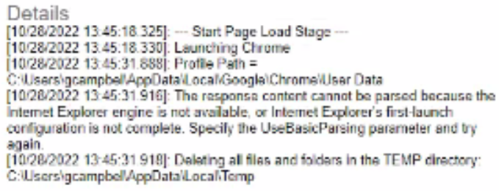

This error is occurring because Internet Explorer or Edge was never opened on the machine prior to the schedule running.

The resolution to this is simple, please follow the steps below.

1. Open IE/Edge on the endpoint machine.
2. Run the GAAM Schedule again.